***ABHISHEK SHARMA***

***500067644***

***DEVOPS B1***

**BRM EXP-9**

# Aim: Build Profile using Maven

**Start: -**

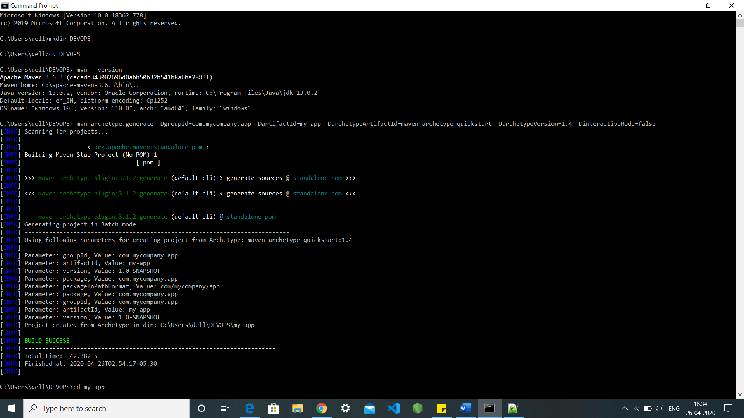

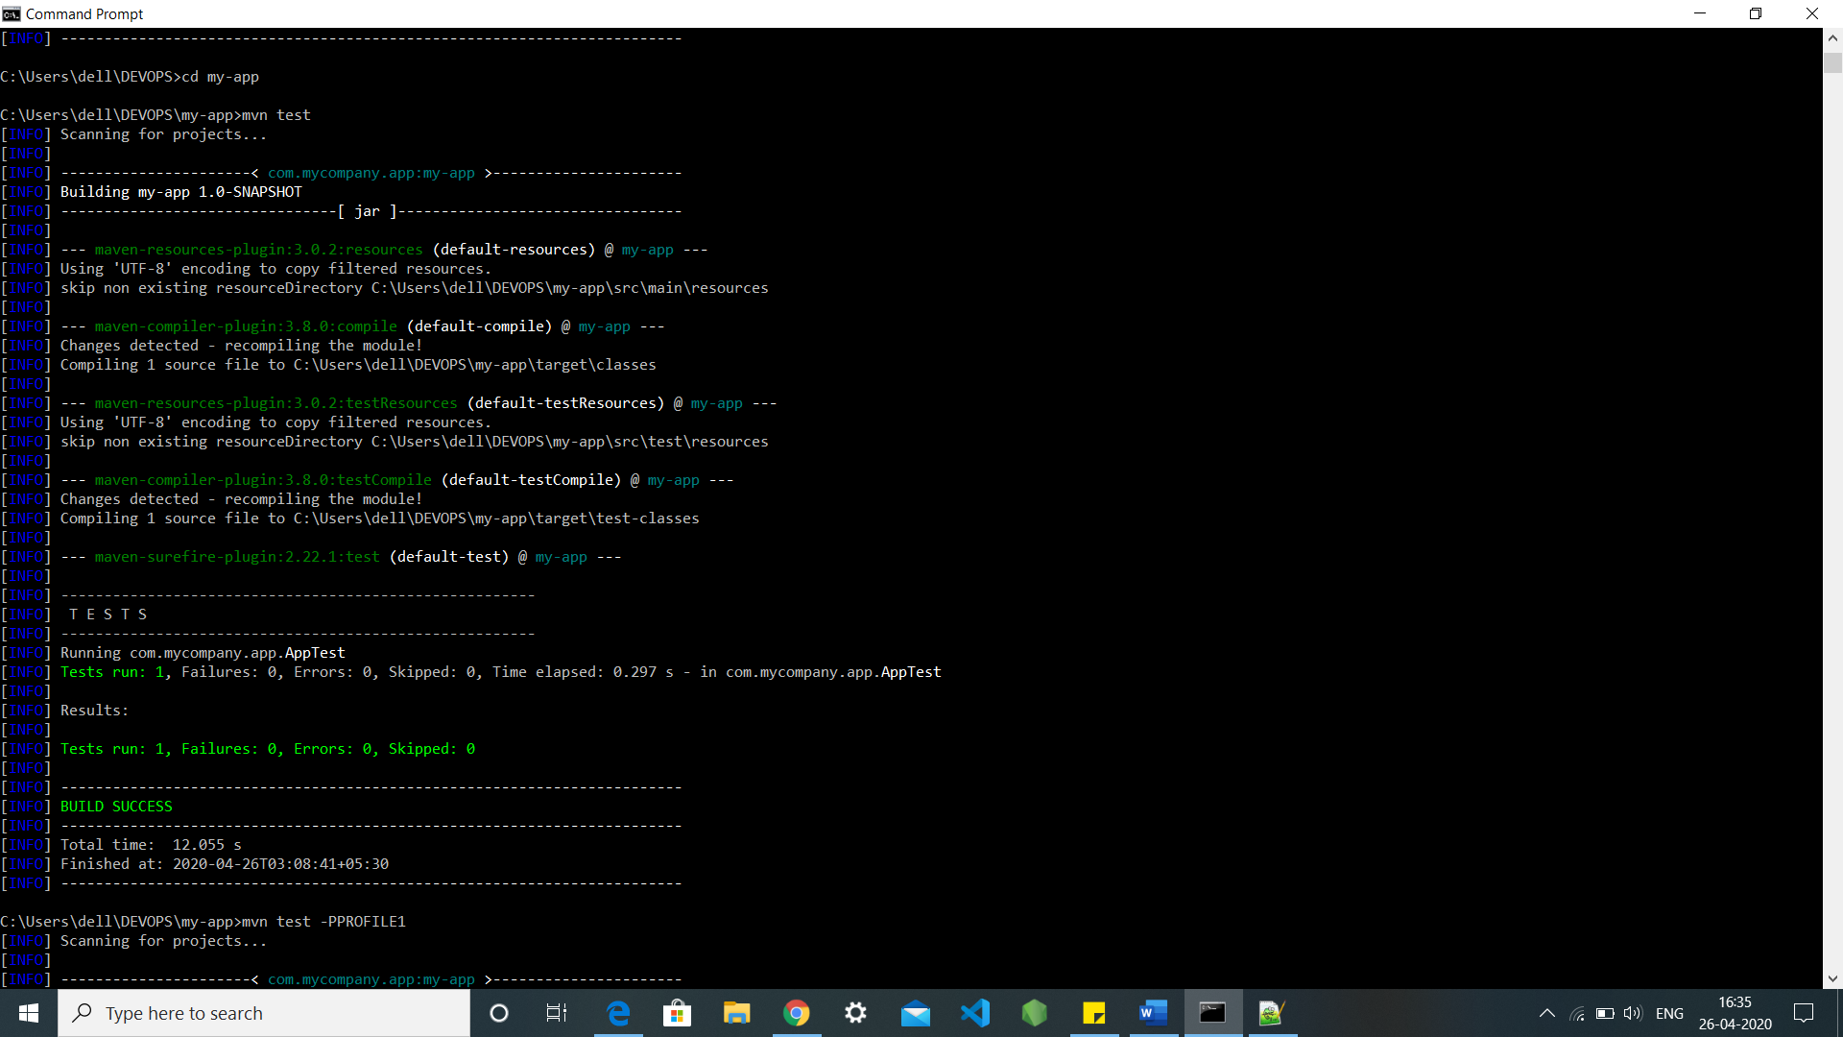

There are several methods to implement the Build profile run, they are as follows: -

**Method 1: -**

Add profile stack into the pom.xml file and run through cmd using -P(profilename)

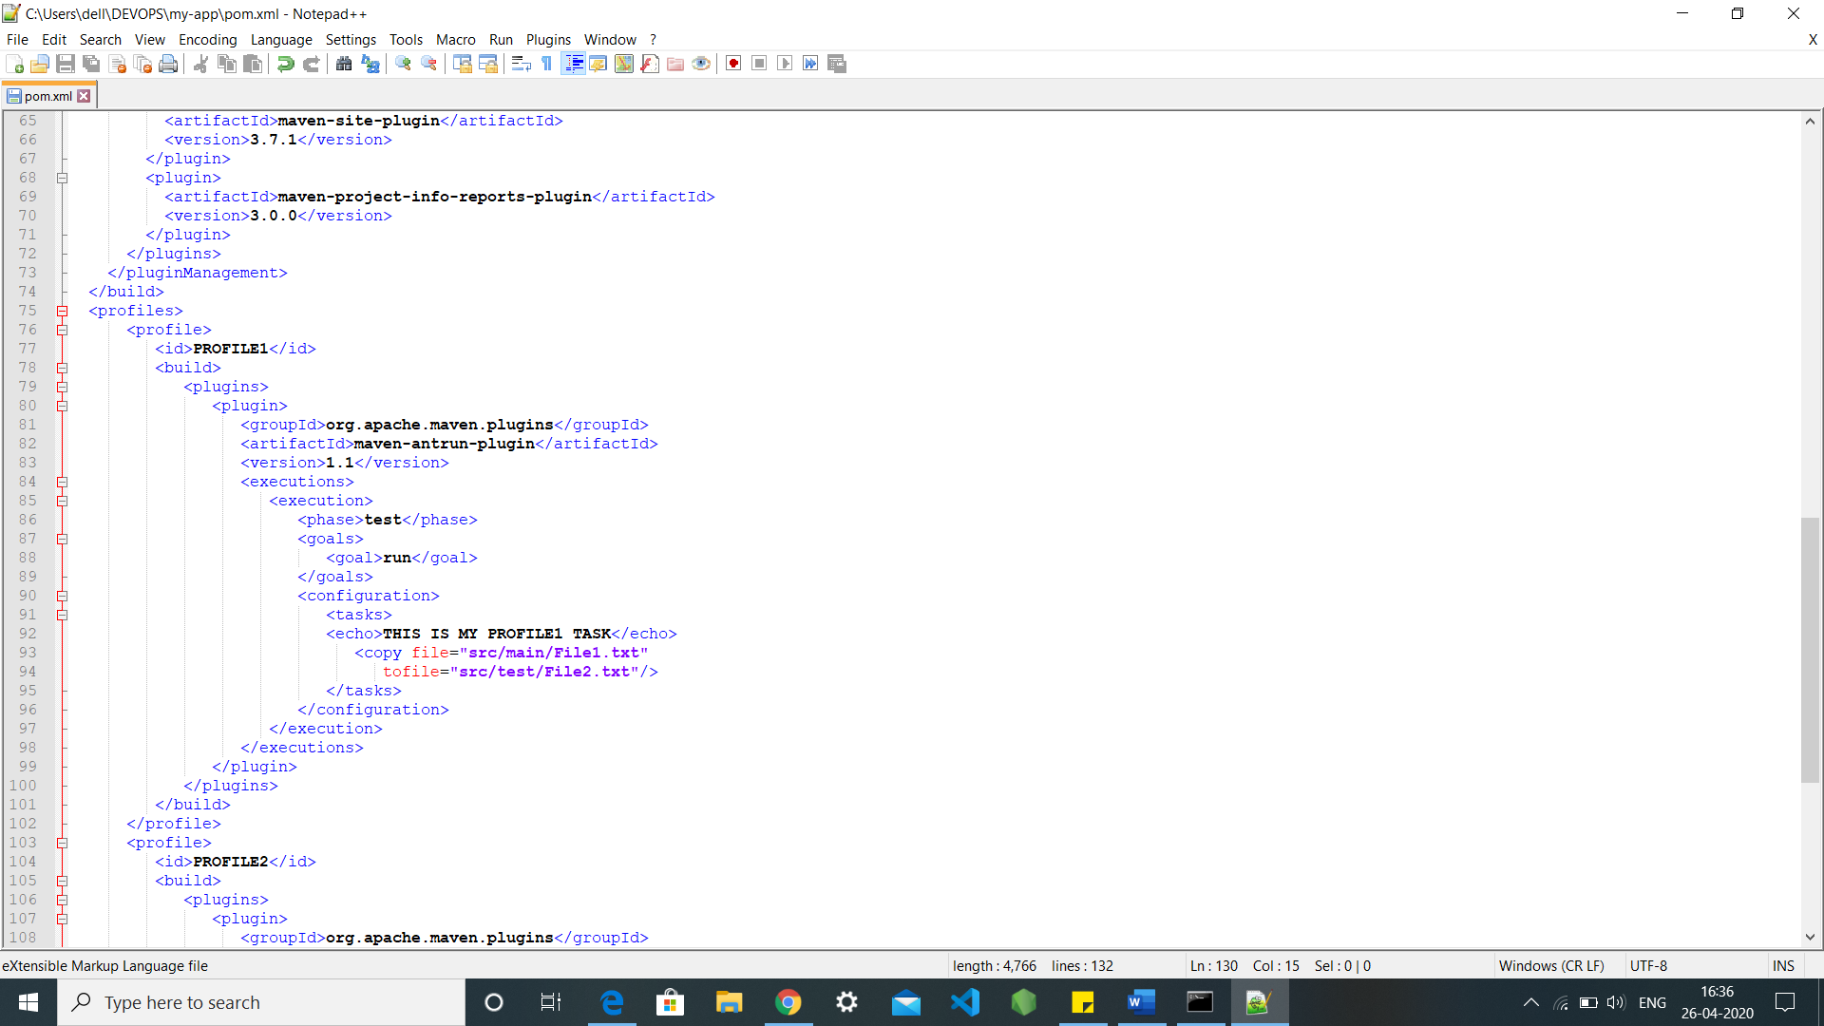

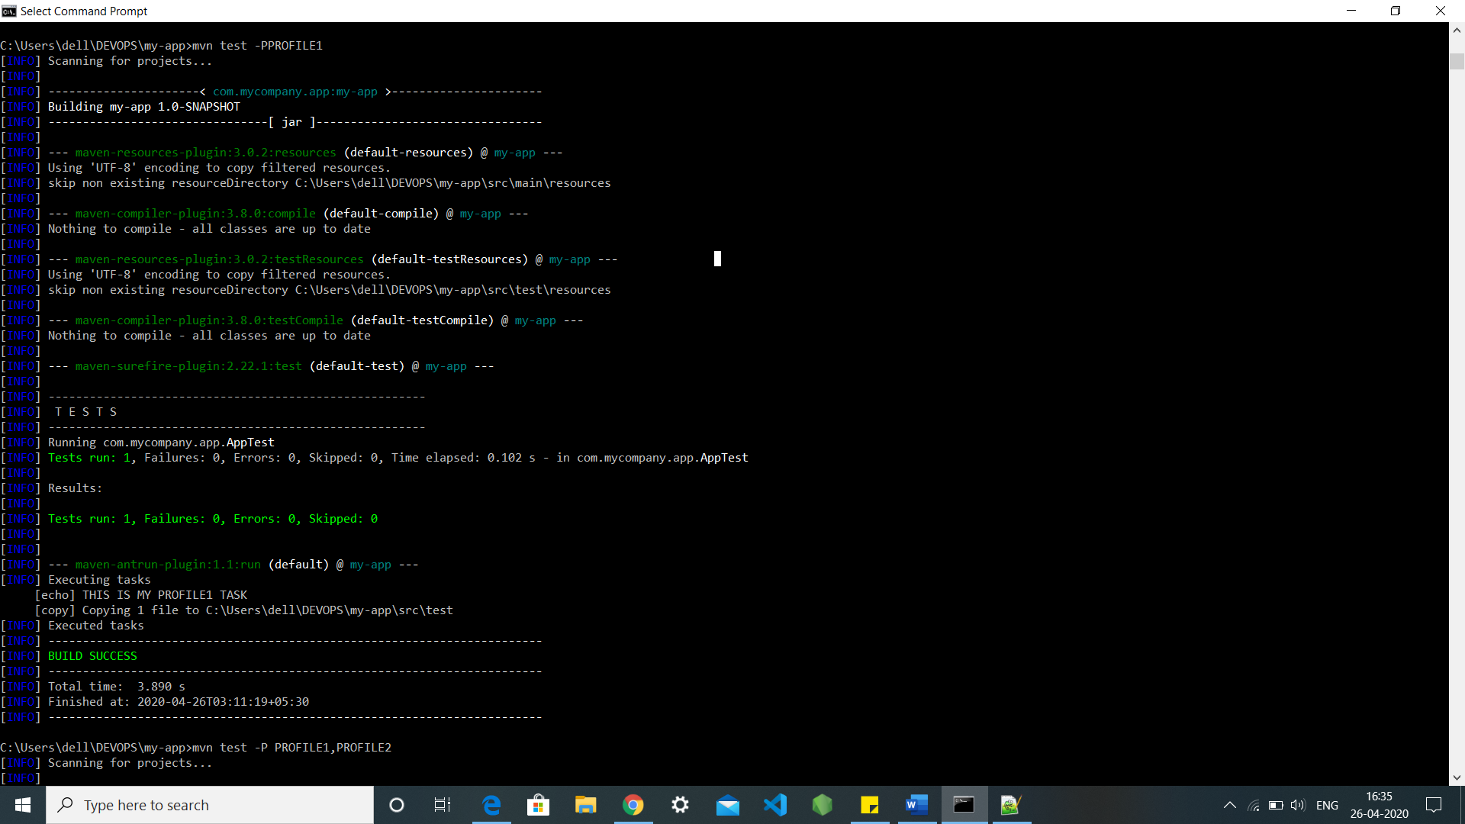

**Method 2: -**

We can execute multifile profiles though cmd with the command -P(profilename1,profilename2)

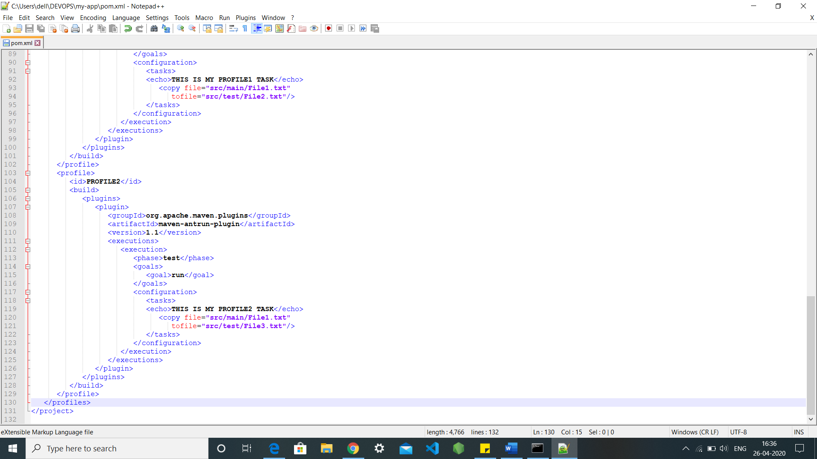

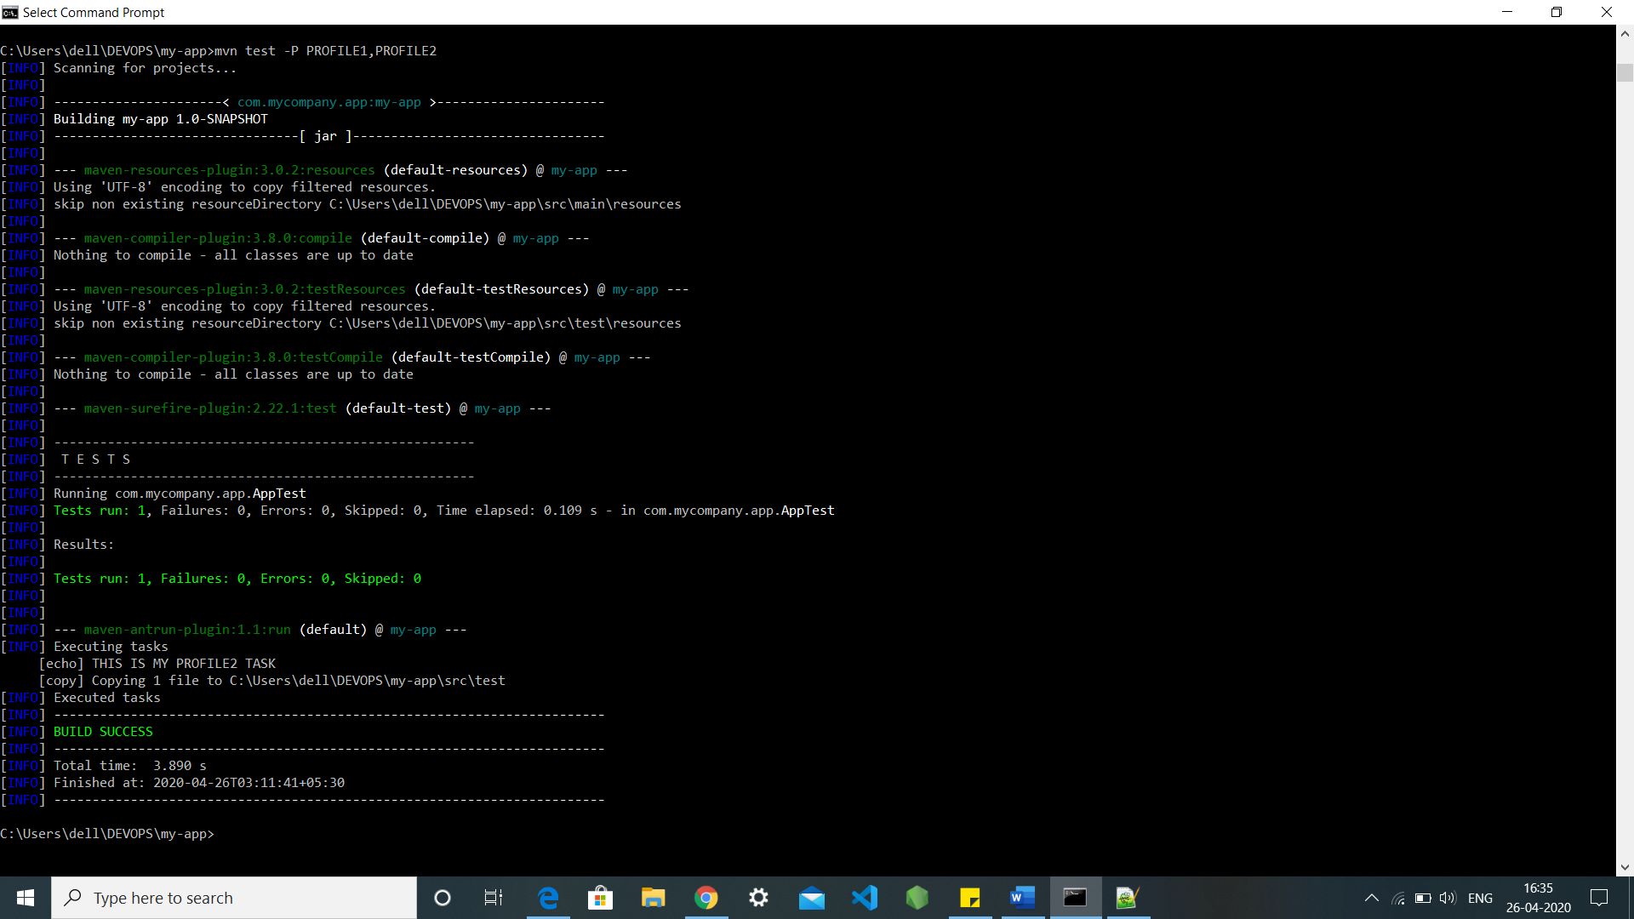

**Method 3: -**

If we ant to run the all the profiles available in the project for this we need to edit into user home Settings.xml file and add all the profile id’s into it and hence we can execute all the profiles in one go though cmd by using the command mvn test

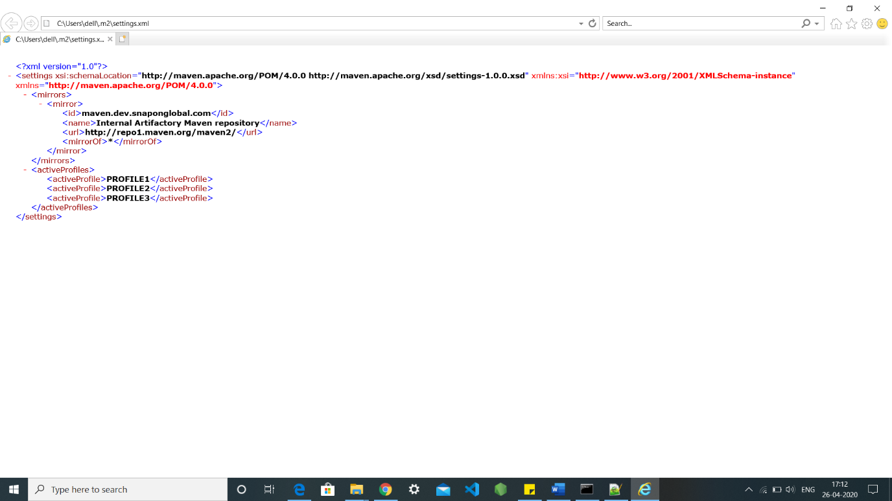

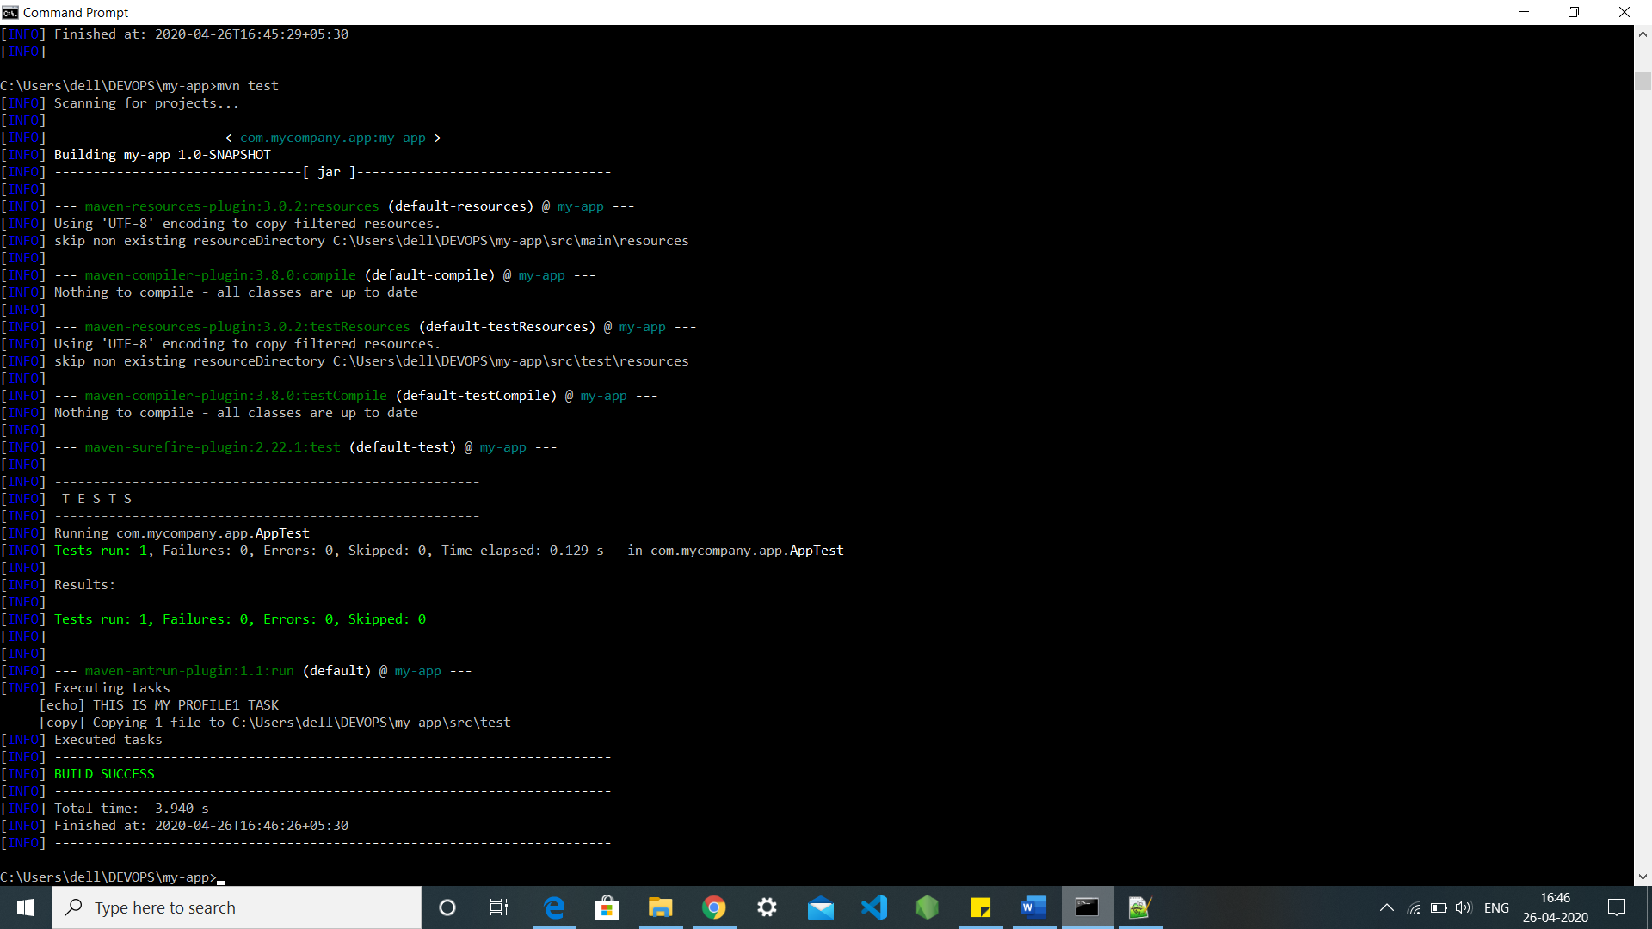

**Method 4: -**

We can also execute the profile but adding some limitations into the pom.xml file like it could only be executed when your system consists of windows XP with some specified version of it.

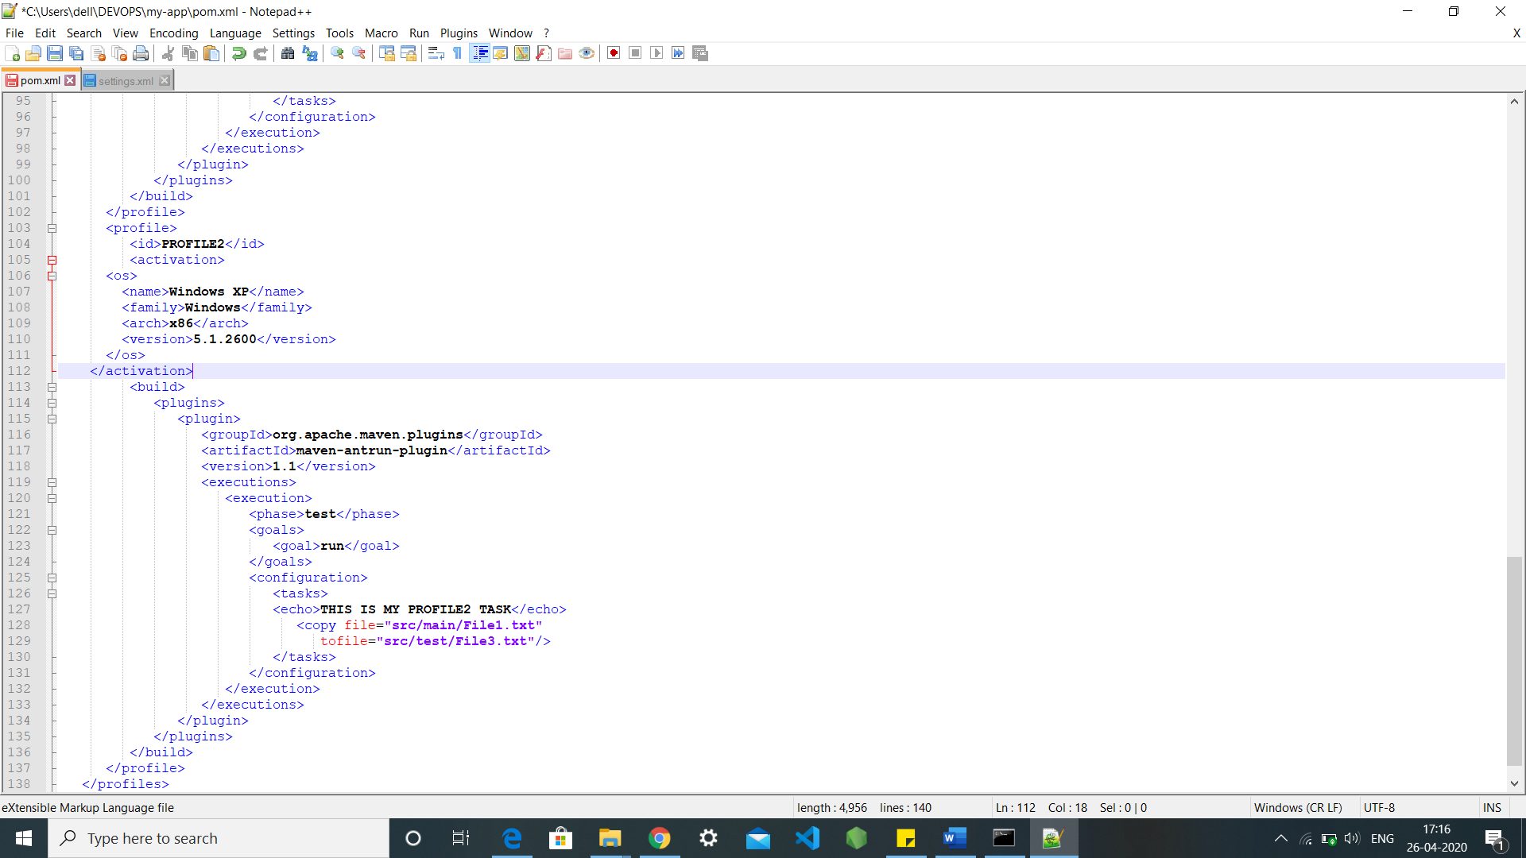

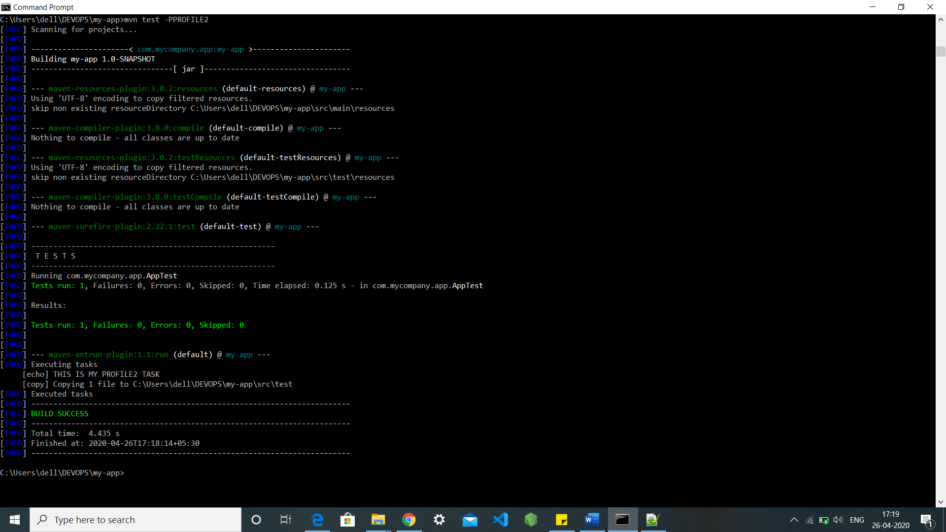

**Method 5: -**

To execute the profile we can also write the activation stack into the profile stack that will always be true to run the profile through the cmd using the command mvn test.

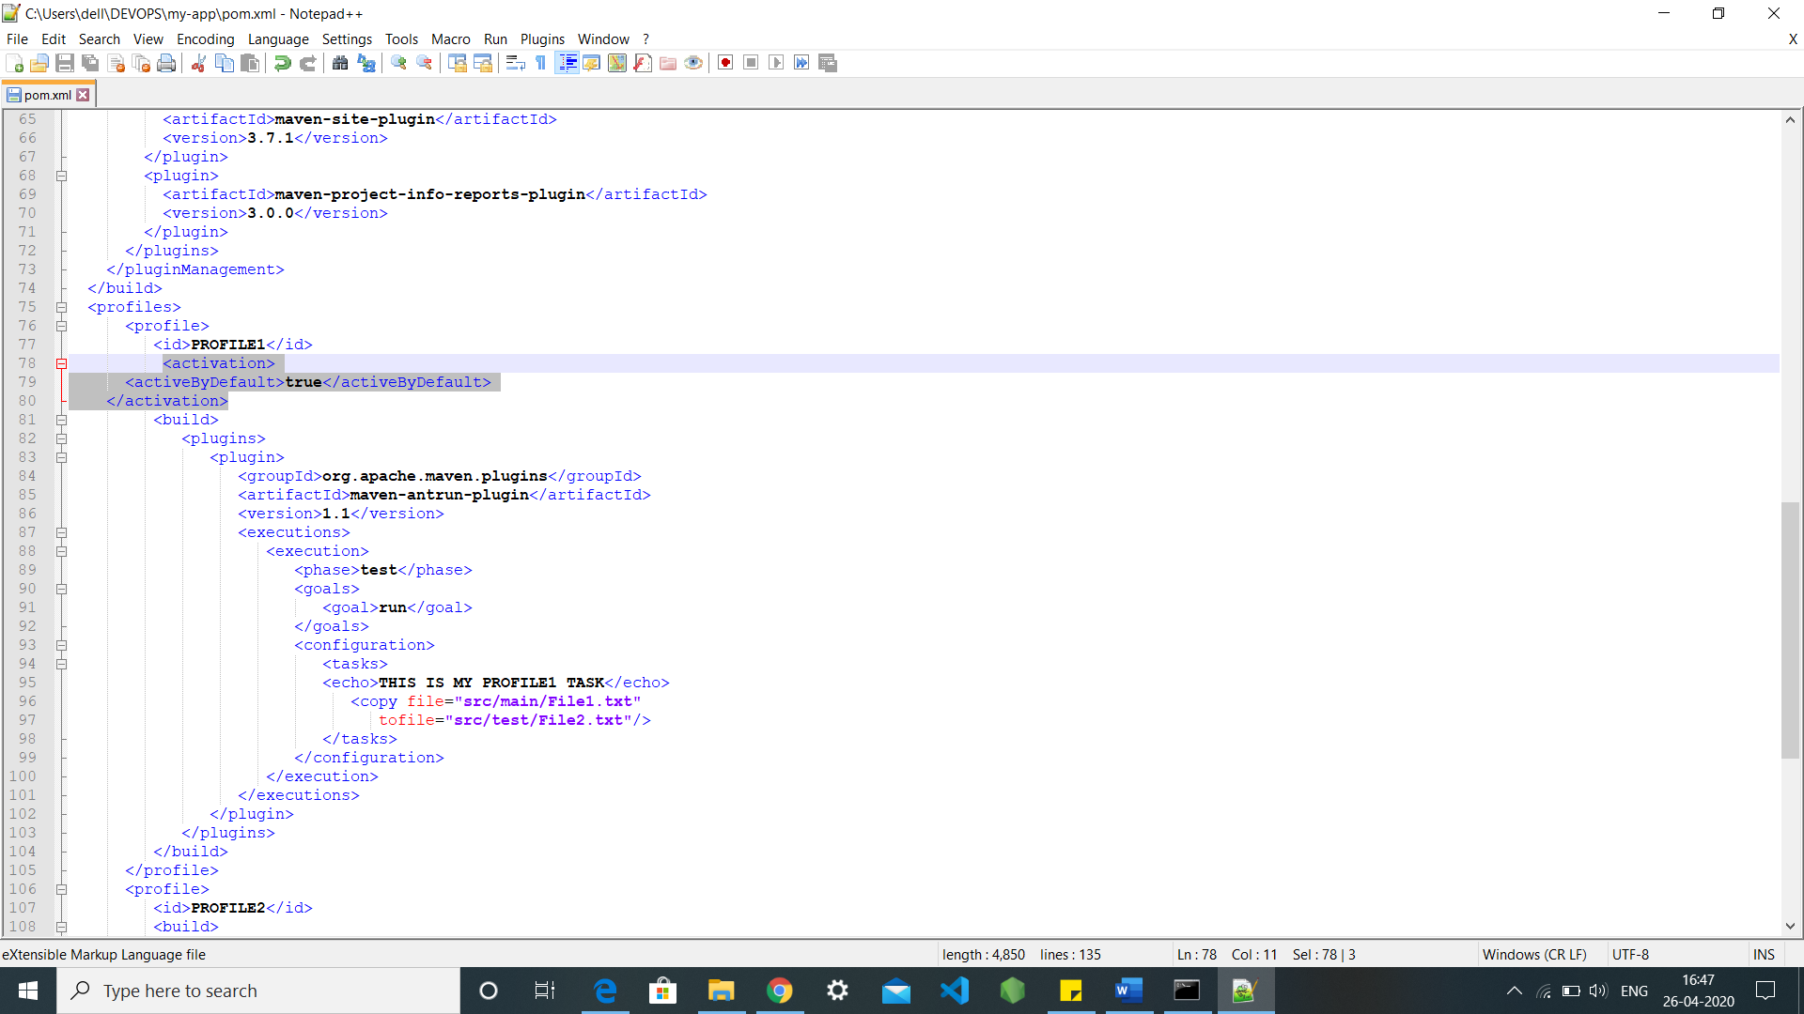



**Method 6: -**

By using Debug we can execute our profile though the command mvn test -Ddebug=true

.

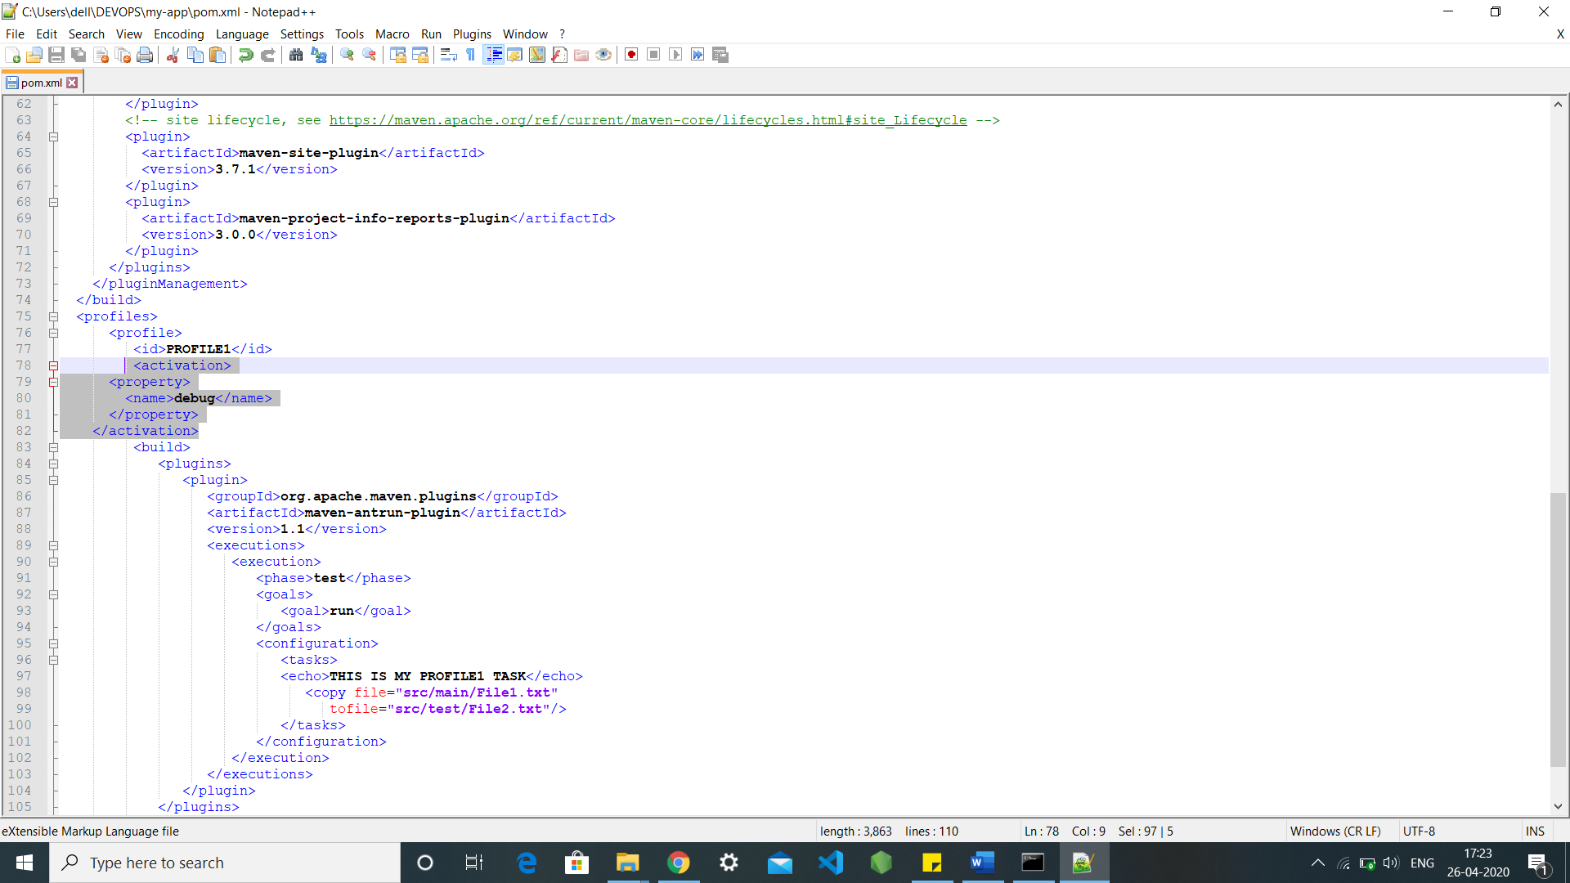

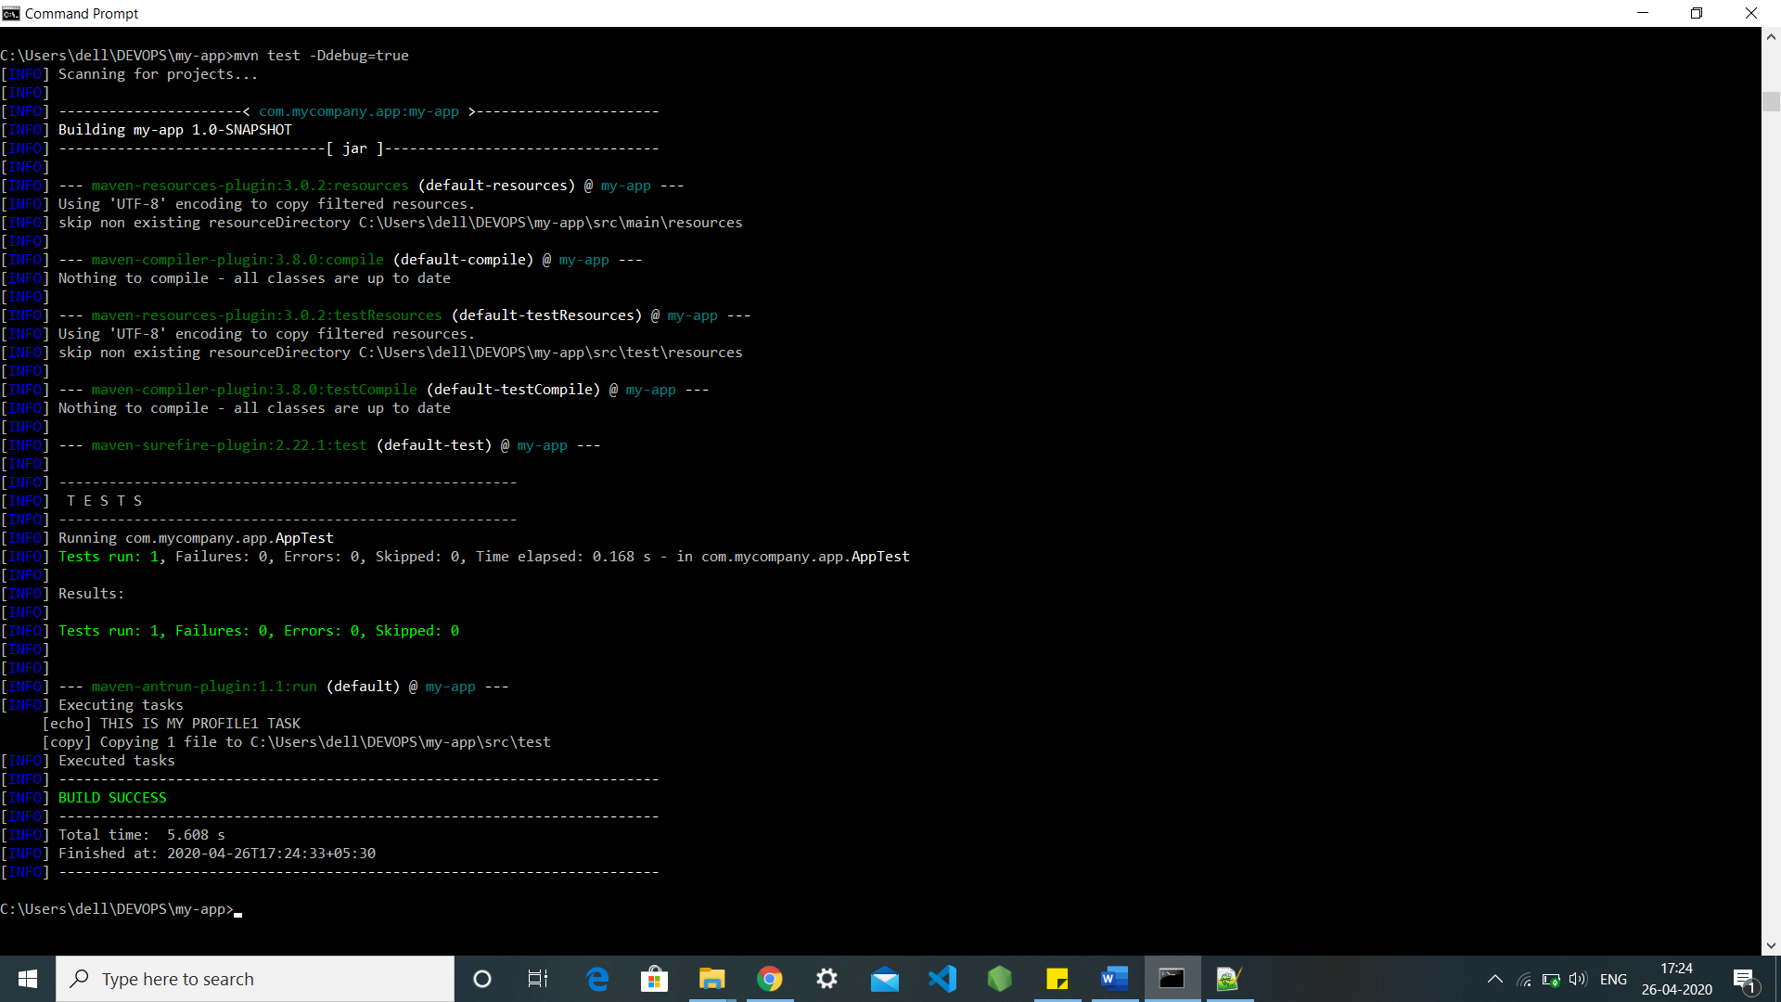

**Method 7: -**

We can also do this by setting up some set specified environments into out profile to execute them so the no one except us can run our secret profile using cmd through the command mvn test -Denv=test

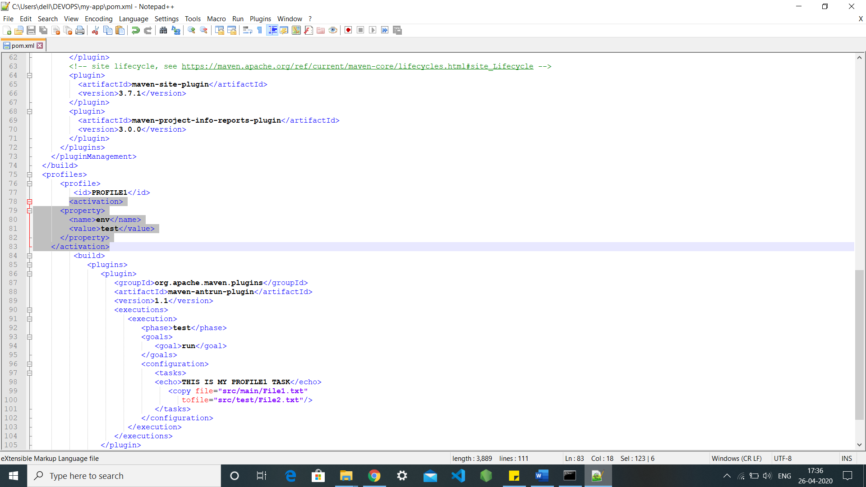

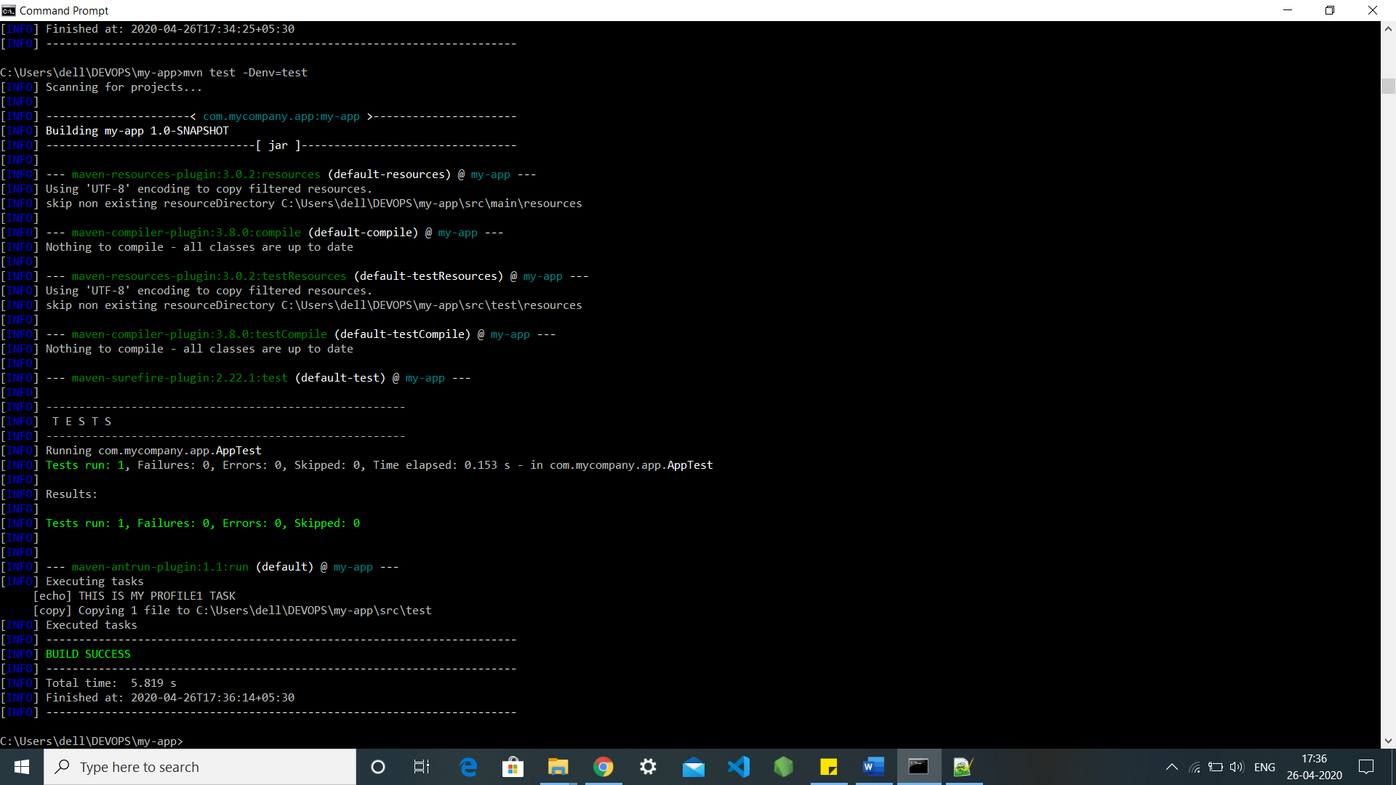

**Method 8: -**

We can also make it run through the unknown file present in our systems using the command mvn test.

